- Create a Weather App using react.
Coding:
import { useState } from "react";
import "./App.css";

function Weather() {
const [city, setCity] = useState("");
const [weather, setWeather] = useState(null);

const API_KEY = "YOUR_API_KEY";

async function getWeather() {
if (!city) return;

const response = await fetch(
`https://api.openweathermap.org/data/2.5/weather?q=${city}&appid=bd5e378503939ddaee76f12ad7a97608&units=metric`
);

const data = await response.json();
setWeather(data);
}

return (
<div className="container">
<h1>Weather App</h1>

<input
type="text"
placeholder="Enter city"
value={city}
onChange={(e) => setCity(e.target.value)}
/>

<button onClick={getWeather}>Search</button>

{weather && weather.main && (
<div className="weather-box">
<h2>{weather.name}</h2>
<h3>{weather.main.temp} °C</h3>
<p>{weather.weather[0].description}</p>
<p>Humidity: {weather.main.humidity}%</p>
<p>Wind Speed: {weather.wind.speed}</p>
</div>
)}
</div>
);
}

export default Weather;
Output:
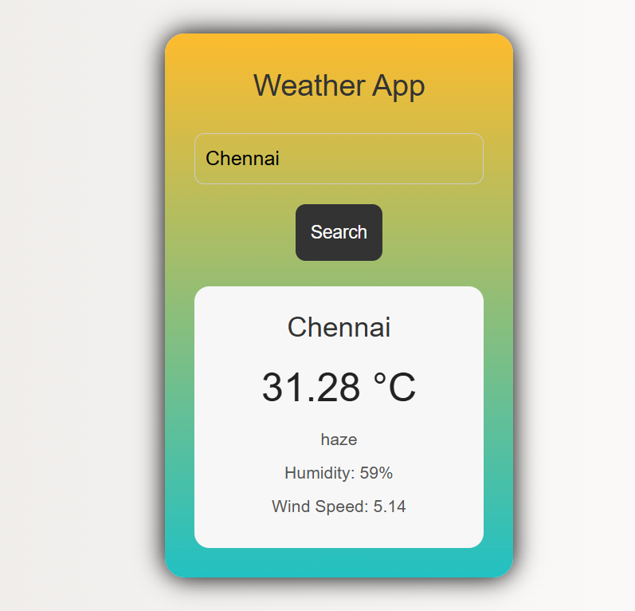

- Create a Calculator App using react.
Coding:
import { useState } from "react";
import "./App.css";

function Calculator() {
const [input, setInput] = useState("");

function handleClick(value) {
setInput(input + value);
}

function calculate() {
try {
setInput(eval(input).toString());
} catch {
setInput("Error");
}
}

function clearInput() {
setInput("");
}

return (
<div className="calculator">
<h1>Calculator</h1>

<input type="text" value={input} readOnly />

<div className="buttons">
<button onClick={() => handleClick("7")}>7</button>
<button onClick={() => handleClick("8")}>8</button>
<button onClick={() => handleClick("9")}>9</button>
<button onClick={() => handleClick("/")}>/</button>

<button onClick={() => handleClick("4")}>4</button>
<button onClick={() => handleClick("5")}>5</button>
<button onClick={() => handleClick("6")}>6</button>
<button onClick={() => handleClick("*")}>*</button>

<button onClick={() => handleClick("1")}>1</button>
<button onClick={() => handleClick("2")}>2</button>
<button onClick={() => handleClick("3")}>3</button>
<button onClick={() => handleClick("-")}>-</button>

<button onClick={() => handleClick("0")}>0</button>
<button onClick={() => handleClick(".")}>.</button>
<button onClick={calculate}>=</button>
<button onClick={() => handleClick("+")}>+</button>

<button className="clear" onClick={clearInput}>
Clear
</button>
</div>
</div>
);
}

export default Calculator;
Output:
